**I.** Logical Arguments

Think back to section 3.1 and how we reason our way to a conclusion. We use ____________ ______________ to look at patterns to help us solve problems. We also discussed that _______________ _________________ uses rules and premises to solve problems, come to a logical solution, or a logical conclusion. So let’s look a little more at deductive reasoning.

A _______________ _________________ is made up of _______________ (assumptions, laws, rules, widely held ideas, or observations) and a _______________. So we use deductive reasoning to draw specific conclusions from given premises. In other words, we reason from premises of an argument to obtain a conclusion and we want our argument to be valid.

What is a valid argument? ______________________________________________________

___________________________________________________________________________

What is an invalid argument? ___________________________________________________

______________ and ______________ do not have the same meaning – an argument can be valid even though the conclusion is false.

**II.** Euler Diagrams

Leonhard Euler (1707-1783), pronounced “Oiler”, was one of the greatest mathematicians who ever lived. The irrational number *e*, is named in his honor, Euler’s number.

Euler diagrams are one of several techniques that can be used to check if an argument is valid or invalid.

Euler diagrams are similar to Venn diagrams. Venn diagrams show **all** possible sets, the universe, and empty sets but Euler diagrams just look at specific subsets related to an argument. The common shape used is intersecting circles.

**Examples of Euler diagrams:**

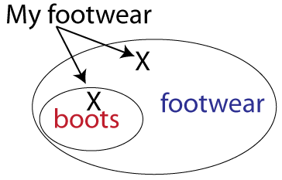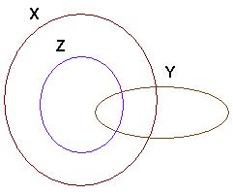

**III.** Logical Arguments with Universal Quantifiers

Universal Quantifiers: _________________________________________________________

Arguments with universal quantifiers are easier to prove valid or invalid.

Is the following argument valid?

Premise #1 All dogs are animals. animals

Premise #2 Max is a dog.

Conclusion Max is an animal.

dogs

*If both premises are true, this forces the*

*conclusion to also be true.*  **X**

Valid or invalid? _________________

**X** represents Max

**EXAMPLE:** Is the following argument valid? Use Euler diagrams to determine if valid or not.

Premise #1 All rainy days are cloudy.

Premise #2 Today is not cloudy.

Conclusion Today is not rainy.

Valid or invalid? _________________

**EXAMPLE:** Is the following argument valid? Use Euler diagrams to determine if valid or not.

All teenagers have cell phones.

That boy has a cell phone.

That boy is a teenager.

Valid or invalid? _________________

**IV.** Logical Arguments with Existential Quantifiers

Existential Quantifiers: _________________________________________________________

Arguments with existential quantifiers are a little harder to prove valid or invalid.

Is the following argument valid?

Premise #1 Some students go to the beach for Spring Break.

Premise #2 I am a student.

Conclusion I go to the beach for spring break.

people who

go to beach for

spring break

*“Some” is existential, meaning some do and some don’t.*

*The premises do not force my conclusion to be true.*

**I I**

Valid or invalid? _________________ students

**EXAMPLE:** Is the following argument valid? Use Euler diagrams to determine if valid or not.

Premise #1 Some trucks have radios.

Premise #2 Some trucks have gun racks.

Conclusion Some trucks with radios have gun racks.

Valid or invalid? _________________